Time Series and Analysis

Sports Popularity Prediction
(Using Time Series Models)

School of Computer Science Engineering and Technology



Bennett University
Greater Noida, Uttar Pradesh

Submitted by: Submitted to:
Pratham Agarwal, E22CSE1308 Dr. Arun Singh Bhadwal
Pranshu Saini, E22CSEU1300
Milind Kashyap, E22CSEU1317

TABLE OF CONTENTS

Section | Title | Page No.
I | Introduction and Objective | 3-4
II | Data Collection and Preprocessing | 5-6
III | Time Series Modeling and Diagnostics | 6-8
IV | Forecasting and Evaluation | 9
V | Discussion and Conclusion | 10-11

I. INTRODUCTION AND OBJECTIVE

Brief Overview:
Time series analysis is a sophisticated statistical method applied to investigate, model, and forecast data that is collected at constant time intervals. This technique helps discover the underlying patterns, trends, and seasonal fluctuations in datasets, which can provide vital insights into the dynamics of the data across time. Time series analysis is highly important in several fields, including banking, healthcare, and most notably, sports. In the world of sports, public attention is typically highly dynamic, altering in response to seasons, tournaments, and key events such as championships, transfers, and player performances. By identifying and understanding these swings in interest, firms may utilize this information to optimize strategy, improve decision-making, and allocate resources more efficiently. The capacity to predict future patterns based on historical data makes time series analysis a vital tool for strategizing in the sports sector.

Concept:
The concept behind this project is rooted in the observation that global sports leagues—such as the NBA, Premier League, La Liga, and NFL—generate large quantities of public attention, which fluctuates over time. These swings are not random but rather related to certain cyclical events within the sports calendar, such as season openers, playoffs, and finals, as well as unexpected circumstances like player transfers or huge scandals. With access to tools like Google Trends, which gathers real-time data on public search behavior, we can follow and evaluate how fans engage with these leagues at different times. The goal is to model these trends and predict when interest will peak or wane, allowing important stakeholders—like advertisers, broadcasters, and sports organizations—the power to make informed, proactive decisions.
For instance, if we can predict when interest in the NBA or the Premier League will surge dramatically, broadcasters may change their content schedules or advertisers could customize campaigns to reach the broadest possible audience. This proactive approach would maximize event scheduling, marketing activities, and overall resource allocation, ensuring that the right messages and events reach the right audiences at the right times.

Objectives:
- To Research and Forecast Popularity Patterns of Major Sports Leagues (NBA, Premier League, La Liga, NFL):
This project tries to assess and anticipate the popularity trends of the selected sports leagues based on past Google Trends data. By exploring these data, we may uncover how interest in each league grows over time, identifying peaks and troughs that correspond with specific events in the sports calendar. This analysis will serve as the cornerstone for the project, enabling the building of prediction models that forecast future interest levels.
- To Assess the Performance of Different Time Series Forecasting Models:
A main purpose is to analyze and compare several time series forecasting models, including Naive, ARIMA, and SARIMA. Each model will be examined for its ability to capture the dynamics of sports-related search patterns and how effectively it predicts future interest. The study will explore the merits and shortcomings of various models, particularly in terms of their capacity to handle seasonality, trends, and unexpected variances in the data. By comparing these models, we will discover the best technique for anticipating public interest in sports.
- To Identify Seasonal Patterns, Long-Term Trends, and Unexpected Fluctuations in User Interest:
This purpose focuses on revealing the hidden seasonal patterns and long-term trends in sports-related public interest, as well as identifying any unanticipated changes that might arise due to external influences. These patterns could include periodic increases during playoffs or tournaments, or long-term fluctuations in fan engagement due to changes in team success or league popularity. Additionally, the initiative tries to explore how external factors—such as media coverage, player movements, and world events—impact public interest in sports. By recognizing these variables, we may acquire deeper insights into the causes influencing fan engagement.
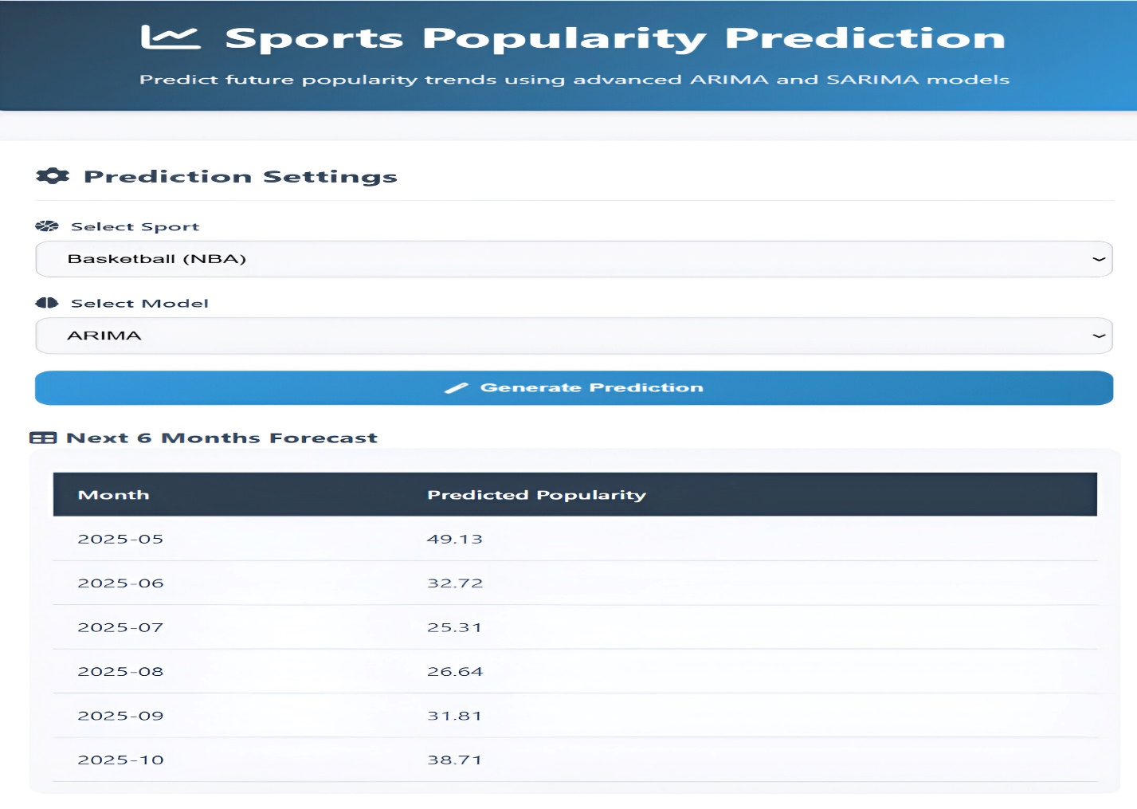
Figure 1: Year-wise Prediction of Basketball Popularity (Sports Popularity Prediction Dashboard).

II. DATA COLLECTION AND PREPROCESSING

Dataset Description:
Source:
The dataset utilized in this research was sourced from Google Trends, a widely recognized and publicly accessible service that tracks the relative frequency of search queries across various geographies and durations. Google Trends harnesses data from Google's huge user base to offer insights into the popularity of specific search keywords, reflecting public interest in various subjects, events, and occurrences. This dataset gives an ideal opportunity to evaluate how public engagement with sports leagues evolves over time, allowing us to understand interest patterns connected to specific seasons, tournaments, and significant sporting events.
Data Type:
The dataset comprises of weekly search interest scores for major worldwide sports leagues, including the NBA, Premier League, La Liga, and NFL. These interest scores are standardized on a scale from 0 to 100, where 100 marks the maximum observed level of interest for the specified time frame, representing the peak frequency of the search query. A score closer to 0 shows decreased interest, proportionally suggesting a relative decline in search activity. These scores are valuable as they indicate real-time public mood and interaction with sports leagues, making them perfect for forecasting purposes and capturing patterns in fan interest.

Pre-processing Steps:
Handling Missing Values:
In time series analysis, it is vital to maintain data continuity and correctness, especially when dealing with real-world data like Google Trends, which may contain gaps or missing numbers. For this project, time-based interpolation was applied to fill in any missing data points. Interpolation works by predicting the missing values based on the surrounding data points, effectively bridging the gaps while retaining the natural temporal flow of the collection. This strategy preserves the integrity of the time series and prevents the introduction of errors or biases that could occur from merely discarding incomplete data.
Outlier Removal:
Outliers can dramatically alter the results of time series modelling, leading to erroneous forecasts and a poor match for the underlying patterns. Therefore, outlier detection and removal were carried out on the 'NBA' dataset to boost the data quality. The Interquartile Range (IQR) approach was chosen for this work. In this method, data points that fall outside 1.5 times the IQR above the third quartile or below the first quartile are termed outliers. By removing these outliers, the research becomes more robust, and the models constructed using the data are more prepared to reflect the genuine underlying patterns of public interest in the NBA.
Stationarity Check:
For reliable forecasting, especially with models like ARIMA and SARIMA, stationarity is a basic assumption. A stationary series is one where the statistical features (such as mean and variance) do not change over time. To ensure the datasets were acceptable for time series modelling, an Augmented Dickey-Fuller (ADF) test was conducted. The ADF test tests whether a unit root is present, which would indicate non-stationarity in the data. If the test results revealed non-stationarity, differencing techniques were performed iteratively to alter the series until it matched the stationarity criterion. This phase assures that the time series models will give dependable and accurate forecasts by removing trends or seasonality that could otherwise lead to misleading results.
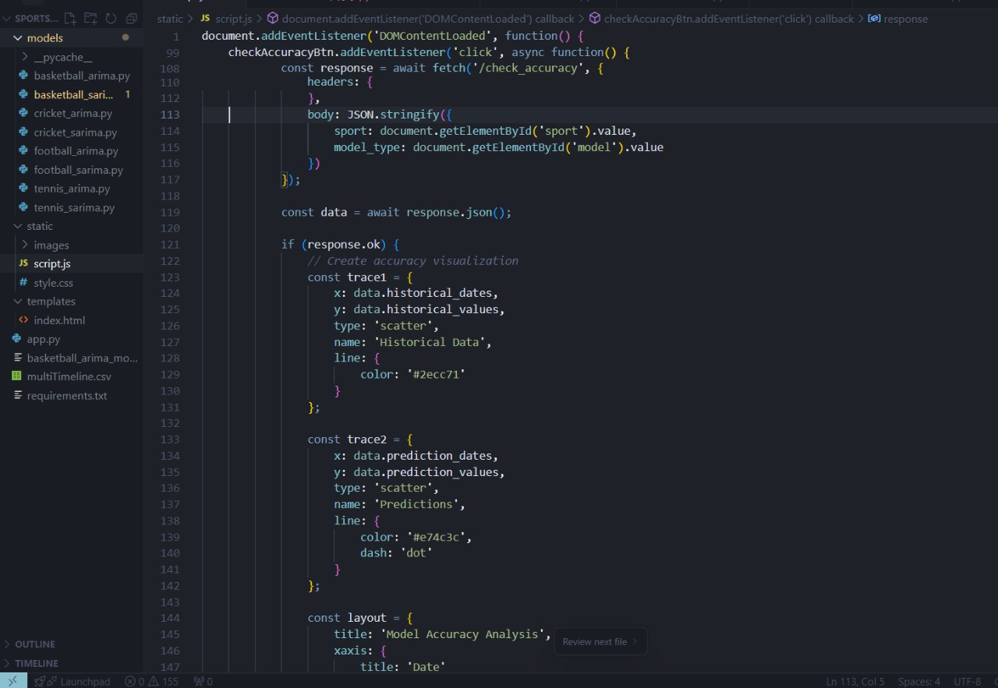
Figure 2: Pseudocode of the project.

III. TIME SERIES MODELING AND DIAGNOSTICS

Model Selection and Fitting:

ARIMA Model:
The Auto-Regressive Integrated Moving Average (ARIMA) model was used to datasets where no notable seasonal patterns were identified.
ARIMA is a commonly used statistical technique for time series forecasting, and it is particularly well-suited for modeling non-seasonal data.
The ARIMA model is made on three primary components:
- Auto-Regressive (AR): This element of the model captures the relationship between an observation and a number of lagged observations (prior values) in the time series. It identifies the temporal reliance on preceding values.
- Integrated (I): The integration component reflects the differencing of the time series data to make it stationary, erasing trends or long-term dependencies. Differencing is done to eliminate non-stationary behavior from the dataset.
- Moving Average (MA): The moving average section provides for the short-term dependencies by analyzing the relationship between an observation and a residual error from a moving average model applied to lagged data.
The success of the ARIMA model lies in the careful selection of its parameters: p (the number of lag observations included in the model), d (the number of times that the raw observations are differenced), and q (the size of the moving average window).
These parameters are changed and optimized by various selection criteria such as AIC (Akaike Information Criterion) and BIC (Bayesian Information Criterion) to build a model that reliably predictions the time series without overfitting or underfitting.

SARIMA Model:
The Seasonal ARIMA (SARIMA) model was applied for datasets when seasonal trends were strong and could not be disregarded.
SARIMA expands the ARIMA framework by integrating seasonal components, enabling it to represent time series with seasonal changes.
The other seasonal components are:
- Seasonal Autoregressive (SAR): This component models the link between the current observation and the past seasonal observations (lagged data).
- Seasonal Differencing (SI): Similar to the integration part of ARIMA, seasonal differencing is done to remove seasonal trends from the data.
- Seasonal Moving Average (SMA): This portion resolves short-term seasonal dependencies by accounting for the link between observations and lagged residuals at the seasonal period.
By combining these seasonal features, SARIMA can predict and forecast periodic patterns that appear in many sports datasets, such as increased interest in leagues during playoffs, finals, or high-profile competitions.
This model's ability to explicitly account for seasonal cycles makes it more accurate for data that demonstrates recurrent behavior over a fixed period.

Model Diagnostics:

Autocorrelation Check:
After fitting both ARIMA and SARIMA models, the residuals (the discrepancies between actual and anticipated values) were assessed for any remaining autocorrelation.
Autocorrelation happens when the residuals are associated with one other, which can suggest that the model has not fully captured all patterns in the data.
To assess this, Autocorrelation Function (ACF) graphs were utilized.
The ACF plots clearly demonstrate the correlation between a series and its lagged values, allowing us to check whether any substantial autocorrelation exists.
If no significant autocorrelation is evident in the residuals (i.e., the residuals behave like white noise), this shows that the model has effectively captured the underlying structure in the data and is good for predicting.

Normality of Residuals:
One of the assumptions of time series forecasting models like ARIMA and SARIMA is that the residuals should follow a normal distribution.
This is vital because it ensures that prediction intervals around the forecast are dependable and accurate.
Histograms and Q-Q (Quantile-Quantile) plots were applied to visually evaluate the distribution of the residuals.
A Q-Q plot contrasts the quantiles of the residuals against the quantiles of a conventional normal distribution.
If the residuals are regularly distributed, the points on the Q-Q plot should lay approximately along a straight line.
This check helps to confirm the correctness of the model and verifies that the error terms are unbiased and random.

Stationarity Confirmation:
A stationary time series has a constant mean and variance throughout time, making it more predictable.
Both ARIMA and SARIMA models assume that the series being studied is stationary.
To confirm stationarity, the Augmented Dickey-Fuller (ADF) test was conducted.
The ADF test analyzes whether the series contains a unit root (i.e., it is non-stationary).
If the test finds non-stationarity, differencing techniques are applied to the series to eliminate trends and make it stationary.
Stationarity was confirmed by conducting the ADF test on the raw series and visually analyzing the time series plots after differencing.
Once stationarity was attained, the data was available for ARIMA/SARIMA modeling, ensuring dependable and accurate forecast predictions.
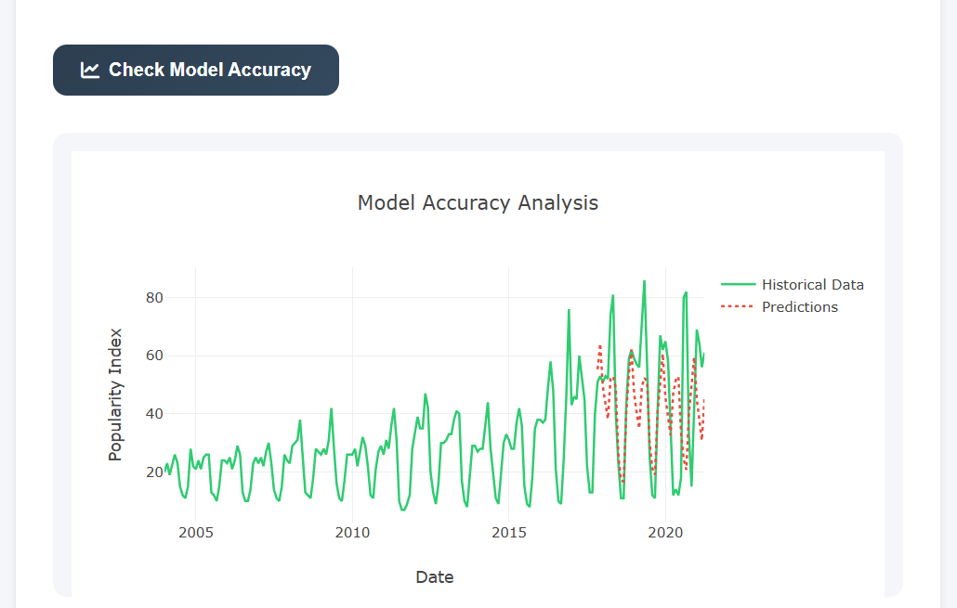
Figure 3: Model Accuracy Comparison Across Different Years.

IV. FORECASTING AND EVALUATION

Key Results:
- Identification of Recurring Seasonal Peaks in Sports Popularity:
The data revealed significant and repeating seasonal patterns in the popularity of major sports leagues. For instance, there was a considerable surge in NBA interest during the playoff seasons, showing the significant impact of the sports calendar on public participation. These seasonal tendencies give significant evidence that fan interest is not evenly dispersed throughout the year but follows predictable cycles connected with key events, tournaments, and playoffs.
- Superiority of SARIMA Models Over Simple ARIMA for Seasonal Sports Data:
While ARIMA models were excellent in capturing overall trends and patterns, SARIMA models consistently beat them when strong seasonality was present in the data. The SARIMA models, which explicitly account for seasonal impacts, offered superior fit and forecast accuracy, particularly for leagues like the NBA, where fan engagement swings substantially with seasonal events. This illustrates the need of including seasonal components when modeling time series data in domains with inherent periodicity.
- Provision of Actionable Forecasts for Scheduling and Marketing Initiatives:
The forecasts given by the models provide significant insights that may be directly used to strategic planning. By anticipating periods of heightened or diminished public interest, sports organizations, marketers, and broadcasters can better organize matches, promotional campaigns, and advertising activities. This data-driven strategy enables for more efficient resource allocation, tailored marketing initiatives, and greater audience engagement during important periods of the sports calendar.
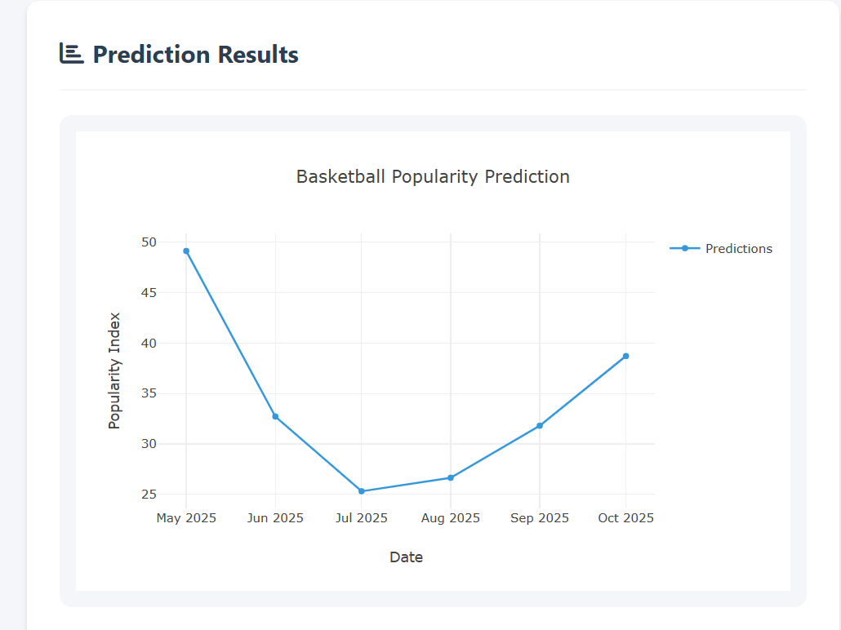
Figure 4: Forecasted Basketball Popularity Trends.

V. DISCUSSION AND CONCLUSION

Results Summary:
The application of ARIMA and SARIMA models to estimate the popularity patterns of major global sports leagues, including the NBA, Premier League, La Liga, and NFL, exhibited remarkable predictive skills. The ARIMA models performed reasonably well across most datasets by capturing underlying trends and patterns. However, SARIMA models demonstrated evident superiority in cases when strong seasonal patterns were present, thanks to their capacity to explicitly include seasonal components. In instance, the NBA's popularity trends were recorded with exceptional precision, demonstrating that past seasonal behaviors (such as heightened attention during playoffs) were accurately predicted by SARIMA. These results confirm the use of time series forecasting algorithms in understanding and anticipating sports audience trends.

Implications:
The findings of this investigation bear various practical implications for stakeholders in the sports industry:
- Strategic Planning for Sports Marketers and Broadcasters:
Organizations can exploit the projected patterns to optimize the timing of events, marketing campaigns, and resource allocation. For instance, campaigns can be strengthened during periods predicted to have surges in public interest, increasing returns on investment.
- Audience Engagement and Ticket Sales Prediction:
Forecasts can help teams and event organizers forecast crowd interest levels and ticket sales volumes during important periods such as season openers, playoffs, and championship games. This can dictate pricing tactics, stadium preparation, and promotional initiatives.
- Broadcasting and Advertising Optimization:
TV networks and streaming services can align advertising slots and broadcast schedules based on predicted peaks in viewership, leading to greater audience targeting and revenue creation.
- Resource Allocation and Staffing:
Event organizers may better manage staffing, security, and venue logistics during high-interest periods, leading to improved fan experiences and operational efficiency.

Restrictions:
While the results are promising, numerous restrictions must be considered:
- Dependence on Historical Patterns:
The models rely extensively on historical data to create future estimates. They believe that past behaviors and trends will generally continue into the future, which may not always be the case.
- Sensitivity to Unexpected Crises:
Unforeseen disruptions—such as worldwide pandemics (e.g., COVID-19), big player transfers, scandals, geopolitical crises, or natural disasters—can drastically affect public interest in ways that the models cannot predict.
- Exclusion of External Influencing Factors:
The models primarily focused on historical popularity trends without integrating external real-time influencers like as media narratives, viral social media trends, abrupt spikes in player or club popularity, or changes in league structures.
- Regional and Demographic Variations:
The investigation did not explicitly factor in variances across countries, regions, or demographic groupings, which might lead to generic results that neglect specific variations in sports interest.
- Data Source Limitations:
Google Trends data, while reflective of public interest, may not fully match with actual viewership figures, ticket sales, or overall fan interaction measures.

